Shahbaj Singh
04/01/2026
CS-305
Certificate Generation
Why would you want to use a CA for security?
Think of a CA like a passport office. It does not create your identity, but it verifies it and stamps it so others trust it. When you connect to a website, there is no way to know just by looking at it whether it is real or a fake copy set up to steal your information. A CA solves this by acting as a trusted third party that has already checked the website's identity and issued it a signed certificate to prove it. Your browser checks that certificate every time you visit, and if something is off, like the certificate is expired, fake, or from an unknown source, it warns you right away. Without CAs in the picture, encrypted connections would still exist, but there would be no way to know who you are talking to on the other end (Crane, 2021).

What are the advantages of using a CA?
The biggest advantage is trust. A CA issued certificate tells your browser, and by extension you, that the server you are connecting to has been verified by someone credible. Beyond that, CAs enable encryption through SSL/TLS, which scrambles the data traveling between you and the server so no one intercepting it can read it. They also maintain revocation lists, meaning if a certificate gets compromised, the CA can flag it, so browsers know not to trust it anymore. For developers, using a CA signed certificate means visitors do not get scary browser warnings, which matters a lot for any real-world application. That said, getting a certificate from a third-party CA costs money and requires a registered domain, so during development it is common practice to generate a self-signed certificate instead. It works the same way technically, but since no CA has vouched for it, browsers will show a warning, which is fine in a local or test environment (IBM, n.d.).

Screenshot of the certificate information form filled out with all fields completed
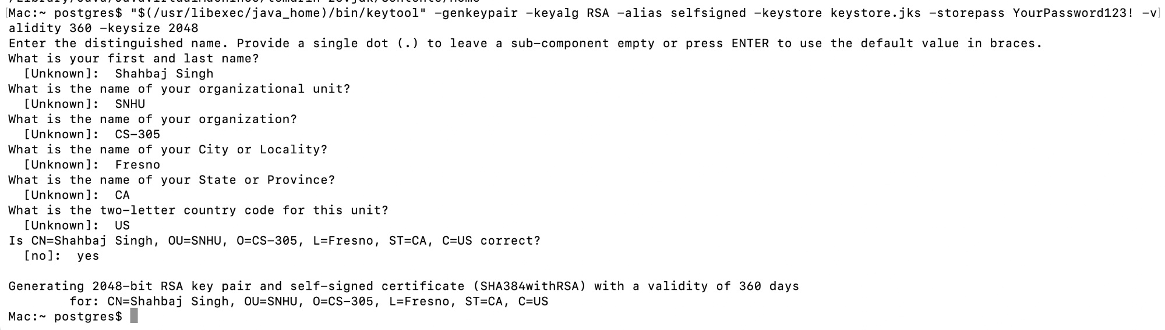

Screenshot of the printout of the server.cer file
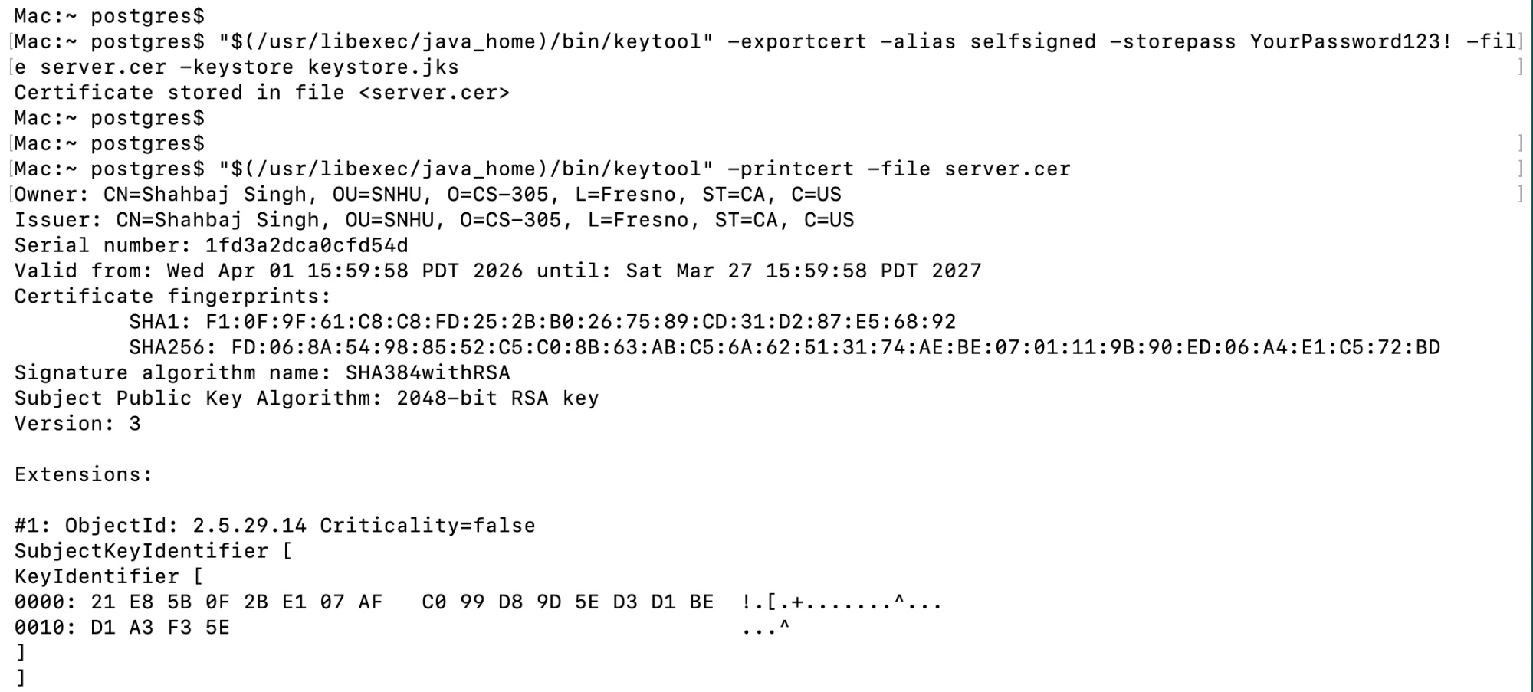

Resources

Crane, C. (2021, June 10). What Is a Certificate Authority (CA) and What Do They Do? Hashed Out by The SSL Store. https://www.thesslstore.com/blog/what-is-a-certificate-authority-ca-and-what-do-they-do/#but-just-how-many-cas-are-there

IBM. (n.d.). Benefits of Self-signed and CA-signed Digital Certificates. IBM.Com. Retrieved October 2, 2021, from https://www.ibm.com/docs/en/b2b-integrator/5.2?topic=certficates-benefits-self-signed-ca-signed-digital-certificates

SSLSTORE. (n.d.). What is an SSL/TLS Certificate? Here’s a Quick Overview. SSLStore.Com. Retrieved October 2, 2021, from https://www.thesslstore.com/new-to-ssl/what-is-ssl-tls.aspx

